**CAACC: Glossary of Hnefatafl**

**Starting Board Format:**

* The game of Hnefatafl is set-up as pictured below:

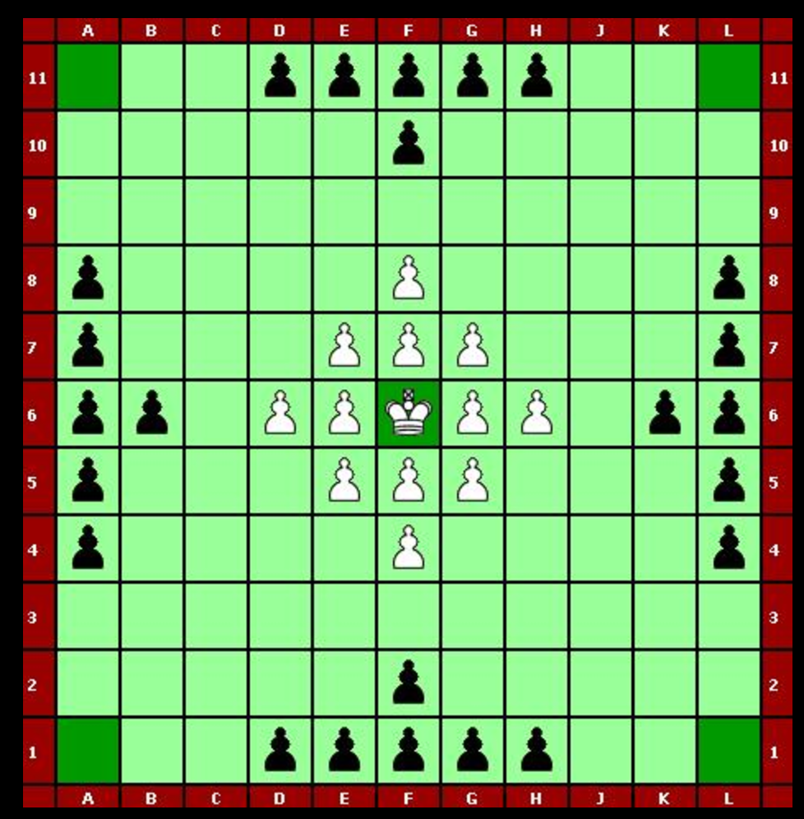

**Rules**

* Objective:
  + **White**: White wins by moving the king to one of the four corner squares.
  + **Black**: Black wins by capturing the white king.
* Movement:
  + All pieces move like a rook in chess. That is, each piece (including the king) may move any number of pieces horizontally or vertically. Pieces may not move into or over a tile occupied by another piece, friendly or hostile.
* Capturing:
  + An enemy rook is captured by “sandwiching” between two friendly rooks. Thus in the picture below, a move by black from the upper to lower blue square would result in the capture of any white rooks on the shaded squares.

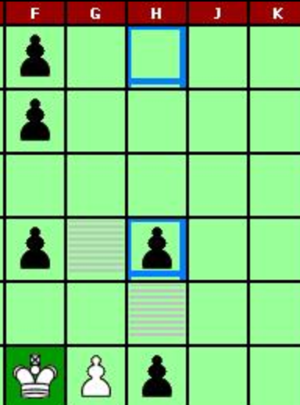

* Capture of the white king is special; the king must be captured through enclosure on all four sides.

**Terms**

* **Attackers**: The black pieces. Their objective is to capture the white king.
* **Defenders**: The white pieces. Their objective is to move the king to one of the four corner squares.
* **King**: The white piece that starts on the throne. White’s goal is to move it to one of the corners, while black’s goal is to capture it. The king has the same movement as a rook
* **Rook:** All pieces that are not the king. They may move any number of spaces vertically or horizontally, but not onto or past a tile where another piece sits.
* **Throne**: The centermost square where the white king starts.

**Conceptual Class Descriptions**

**Match**

Could also be referred to as “Game”. Groups all other game related classes (Board, Tile, Piece, Player) to run the game. Instructs these lower layers to modify their contents depending on the game state.

-Match Status attribute tracks the turns of each player and tracks end-game states (win/loss).

**Player**

Representative of the user playing the game. Basically the identifying object for a person in the game.

-Email attribute is assigned to the system by the player and identifies a user.

-Password attribute is also assigned to the system by the player and verifies the user is who they identify as.

**Profile**

Display for a particular player in game. Contains and displays important information about the user in the scope of the game.

-Nickname attribute represents the chosen pseudonym for a player. This nickname will be displayed in games.

-History attribute is a container for game history and other useful game tracking statistics.

**Board**

Holds Tile information for a given game. Sets up a game for play.

-Board State attribute tracks what the current setup of the board may be; where pieces are via which tiles are occupied.

**Tile**

Contains a Piece representational to what piece occupies a given space at any time.

-Contents attribute identifies what piece is present if one is present at all.

**Piece**

A piece in the game. Holds self-identifying information about its place in the game.

-Position attribute holds coordinates for position on the board.

-Color attribute details which side a piece in on (ie. Black or White)

-Status attribute describes whether the piece is in play or not.

-Type attribute tells the associated classes whether this piece is a king or pawn.

**Invitation**

Identifying class for informing players of invitations to join a given game